## Steps for the Calibration

### Summary of the steps you have to follow to complete a full Calibration:

1. Place Calibration bloc on trolley A. (A1)
2. Move Trolley A to calibration position for tacker
3. Calib_TCP, Calib-UF3, Calib-TCP, Calib_UF3
4. Remove the Ball tip
5. Calibration X-Scanner (7 Scan). Actually we use only 5 of the scans the two others are just to confirm or verify the calibration and this is done only when AGT Vision request it.
6. Put back the ball tip
7. Calib-TCP
8. Don not remove the ball tip
9. Repeat Steps 2 to 8 for the welder
10. Calib TCP+Target
11. Calib_Boulier _MB until pause.
12. Calib-TCP + Target-Monitor R[210] and i9f it is more then 0,3mm repeat steps 10 to 12.
13. Calib_Boulier_TB (Trolley B)
14. From the end of Calib_Boulier_MB move trolley for touching with welder.
15. Calib_Bouiler_WB
16. Calibrate Scanner Line B
17. Repeat Steps 11 to 16 With Line A (Trolley A)
18. Restart the Server (Once if only calibration Manip_2D and twice if RBTT or RBTW).

# Full details of the Beam Master Calibration

## Robot Tacker TCP Calibration (TCP)

1. Setting up the calibration bloc on Trolley A, Easel A1
   1. Bloc must be placed in a specific position see picture below.

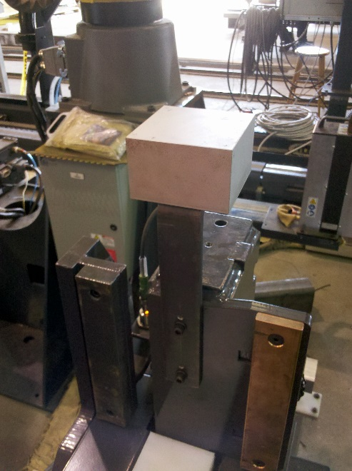

1. Make sure that the bloc is grounded properly before starting. PICTURE. Cette image va falloir que je la fasse chez Owen ou quelqu’un à Trois-Rivières la prenne pour moi.
2. Replace the nozzle and the tip of the Tacker and replace it with the ball tip.
   1. Remove the Nozzle. PICTURE NOZZLE

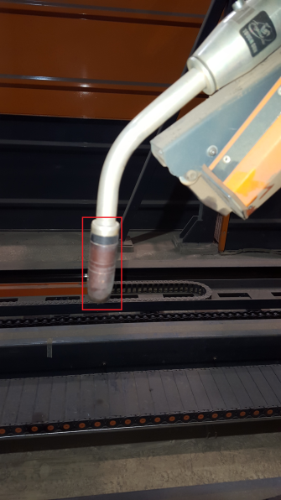 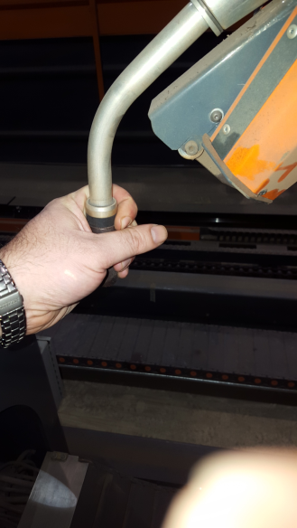

* 1. Cut the extra Welding wire exiting from the welding tip
     1. Or From Teach Pendant click the Shift and ‘-‘ wire button to retrieve the welding wire. ou entrer le fil avec shift + wire “-“ sur le teach pendant.
  2. Remove the tip. PICTURE tip
  3. Install the Ball TiP.

Do not place the Nozzle back.

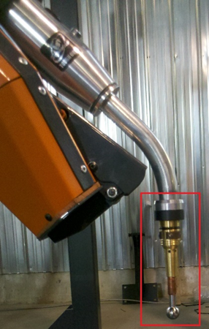

1. Verification that the Bloc is well grounded
   1. On the Teach Pedant of the RBTT look for DO67 [Weld Touch]. DO number may vary from site to site. (Comment on fait pour voir le DO67?)
      1. On the Teach Pendant choose a Display screen, Click the button, Display Until you get to the screen you want. (picture)
   2. On Teach Pendant of RBTT or RBTW Look for DI74[Touch]
   3. How to access those DO and DI are from the Teach Pendants
      1. Select the 3rd display window by pressing the display button
      2. Press the Menu Button
      3. From the Menu Select I/O
      4. Select Digital
      5. Scroll down until you DOXX [Weld_Touch]
      6. This may vary at each client site. If you are not sure you have to look for the Touch.ls program from there you will find what are the right ones. (requested the information from MAA) (comment on fait pour voir DI74?)
   4. Move RBTT ball tip on top of the Bloc in T1 Mode (le robot doit etre probablement en full automatique…) (Non pour le bouger il manuellement il faut que le Controleur soit sur T1 et le teach pendant a ON)
      1. From Teach Pendant
      2. Make sure you are in T1 Mode and the Switch is at on
      3. Press the Deadman switch + Click Shift and –Z to lower it until about 2 cm above the bloc.
      4. With your conductive wire touch one end the bloc the other end of the wire to the ball Tip
      5. DI74[touch] will change status from OFF to ON.
      6. This will confirm that the bloc is grounded properly.
2. Before continuing you will need to go the HMI control panel
   1. Click Settings (Add Picture)

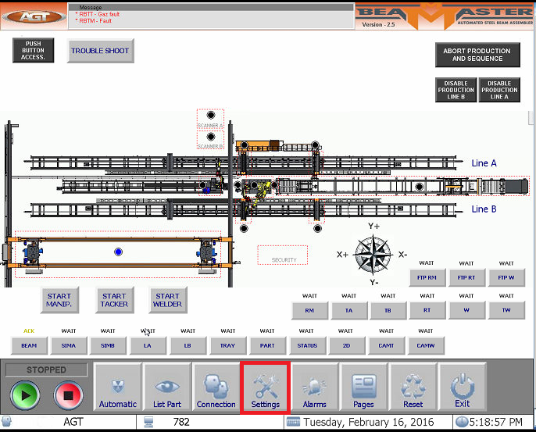

* 1. Click on Calibration button (will change color from Charcoal to Orange)(Add Picture).

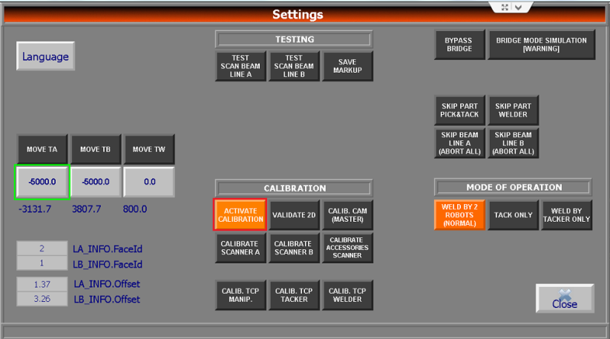

* 1. This means that the Beam Master knows you are in Calibration mode. (et ou il y a le status “running” il y a le mot calibration en jaune aussi je crois) Still Need Picture
  2. Click on button Calib TCP Tacker

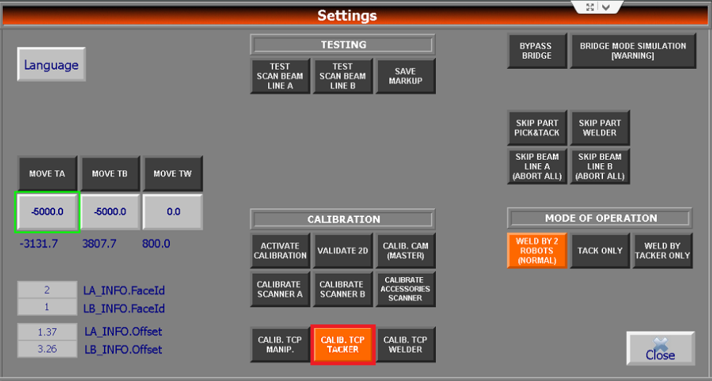

* + 1. The Calib-UF3 will be done automatically (no need to do it manually by Teach Pendant) (a quel moment il peut savoir que c’est terminé?)
    2. When the tacker will go back to its home position or Stop??(ask MAA)
    3. Once click again on the Calib TCP Tacker to deactivate it (Colour changes back to charcoal).

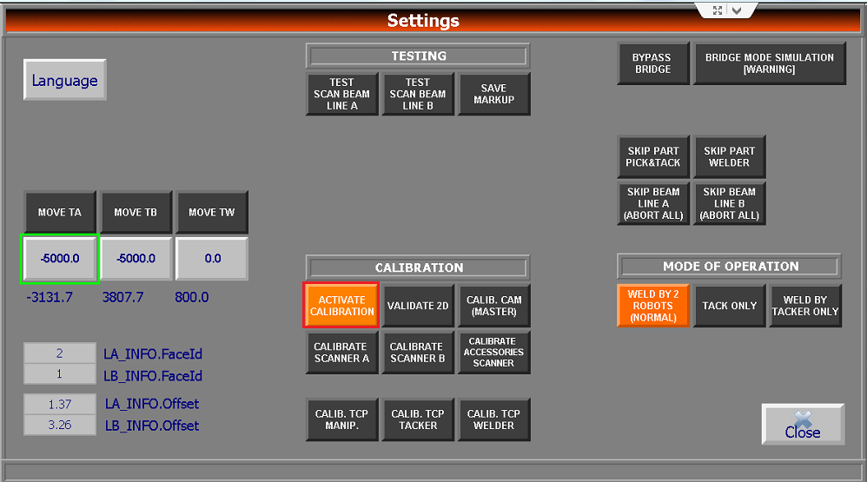

Once done you must do the Calibration of the Welder.

## Robot Welder TCP Calibration (TCP??)

1. Go the HMI control panel
   1. Click Settings



* 1. Click Calibration button To keep it on (button colour must be orange)

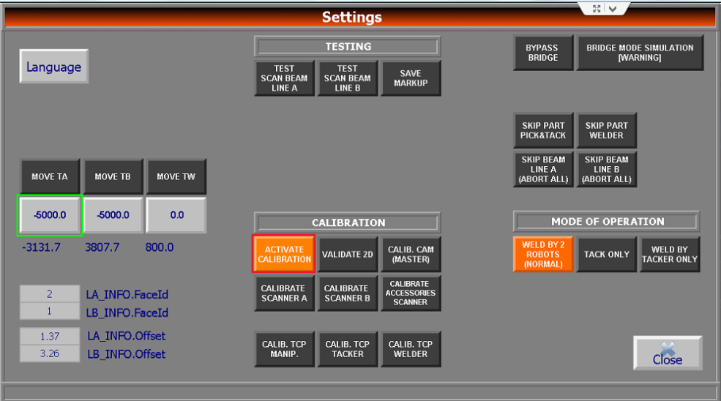

* 1. Click on button Calib. TCP Welder

Add picture

* + 1. The Calib-UF3 will be done automatically (no need to do it manually by Teach Pendant)
    2. Once click again on the Calib TCP Tacker to deactivate it (Colour changes back to charcoal).

## Robot Manipulator TCP Calibration (TCP??)

On the Robot Control you must change the Mode from Auto to T1 and on teach pendant you must turn the TP to On (Top left Switch/Button)

To perform the Manipulator Calibration you must place the Calibration plate first.

### Manip Teach Pendant

On first Display screen of the Manipulator Teach Pendant (add Picture).

There is a program called ‘G1_Plate_On_Off’.

1. From the RBTM Teach Pendant:
   1. Select First Display with the Display button
   2. Click on the Select button
   3. Scroll down with arrows until you see G1_Plate_on_off program
   4. Click Enter
2. From Teach Pendant Press the Deadman switch (under teach pendant)
   1. Click Shift + Forward(once) Keep the Shift button pressed
   2. Until you see a message on the Teach Pendant informing that you can Place the plate

(tu peux dire comment aller trouver le programme..avec le “select”)

This program will place the Manipulator in the proper position to place the Calibration Plate. (Add picture of the Manipulator Calibration Plate). Once done you reselect this program for you to be able to remove the calibration plate.

Once the Robot Manipulator is in position, the magnet status will change to off. This will let you place the plate.

* 1. From teach pendant change the DI?? [Magnet] to On by Pressing F4 (Not Sure).
  2. For each site maybe different here is the latest for each site (J’ai eu cette information plus bas de Martin Amyot aujourd’hui le 16/02/2016)
     1. AGT : DO[28:Magnet On]
     2. LIB 38: DO[89:release magnet]=OFF ;
     3. Line 44: DO[1:Magnet On]=ON ;
     4. Ven 38: DO[24:release magnet]=OFF ;
     5. Line 44: DO[28:Magnet On]=ON ;
  3. Place the plate as indicated in the pictures below.

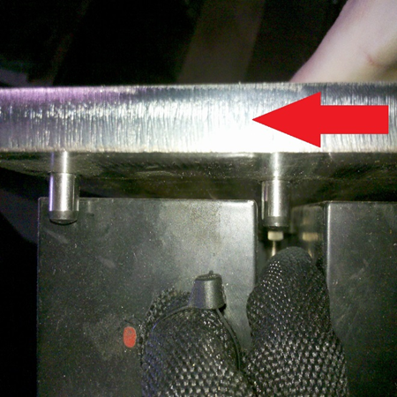 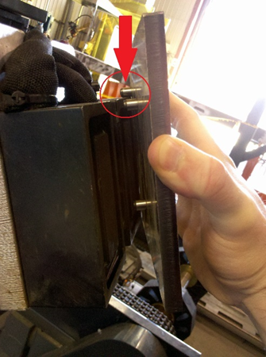

1. Click on Select Button (add picture)
2. Go the HMI control panel
   1. Click Settings
   2. Keep the Calibration button on (button colour must be orange)
   3. Click on button Calib TCP Manip (add picture)
      1. The Calib-UF3 will be done automatically (no need to do it manually by Teach Pendant)
      2. Once click again on the Calib TCP Manip to deactivate it (Colour changes back to charcoal).
   4. To remove the Calibration, from the Teach Pendant select again the TCP_Manip_Plate_On_Off.
   5. RBTM will move in the proper position.
      1. The Magnet will be deactivated automatically.
      2. Remove the Plate.
3. Go to HMI Console Panel
   1. Click on Settings
   2. Click on Activate Calibration button to deactivate the Calibration Mode.

*Remove the ball tips from the RBTT and RBTW. Remove the Calibration Bloc from Trolley A (A1).

## Xscanner Calibration for RBTT and RBTW

For this part you have two scenarios possible:

1. This your first install or run of the beam master do the following:
   1. Start a simulation
   2. Then ‘Mock’ a production by passing the tacks and welds… (Simon a verifier stp)
      1. Click the Service Tack or Service Weld
      2. Click on Bypass Tack button or Bypass Weld???
      3. This will produce an ID for the beam and the beam will be considered produced. (ecrire la procedure s’il n’y en a pas)
   3. If not you can ask the operators the last beam produced or one that has been produced during the day.
   4. Or look in the server and look under C:\Orus\beaminfo, look for the last beam id and check if there pictures in the images folder.

RBTT and RBTW must be in T1 Mode. From the RBTT and RBTW Controllers (Sever side) switch the Key to T1 mode. On Teach Pendant Top left Switch turn it to on

This calibration is done when we suspect that the Xscanner (Laser and camera, Orange box) on the arm of the Robots is miss calibrated or not scanning at the proper position to tack or weld.

At the present time you will need to run the program 5 times.

*Sometimes 7 this is done only to validate the calibration.

One will run the program on the Teach Pendant and another will need to be on the HMI to force the pictures to be saved on the server.

The path on server is:

Tacker:

C:\Orus\images\XscannerTacker

Or

Welder:

C:\Orus\images\XScanner Welder.

1. On the RBTT Teach Pendant there is a program that will help you perform the Xscanner program.
2. You will need someone to be on the HMI also to perform the Save image manually.

Important: Make sure that on server that you have the

### On HMI Console Pannel

#### Xscanner Calibration of Tacker

RBTT and RBTW must be in T1 Mode. From the RBTT and RBTW Controllers (Sever side) switch the Key to T1 mode. On Teach Pendant Top left Switch turn it to on

* From the HMI Console
* Click on CAMT button (Add picture)

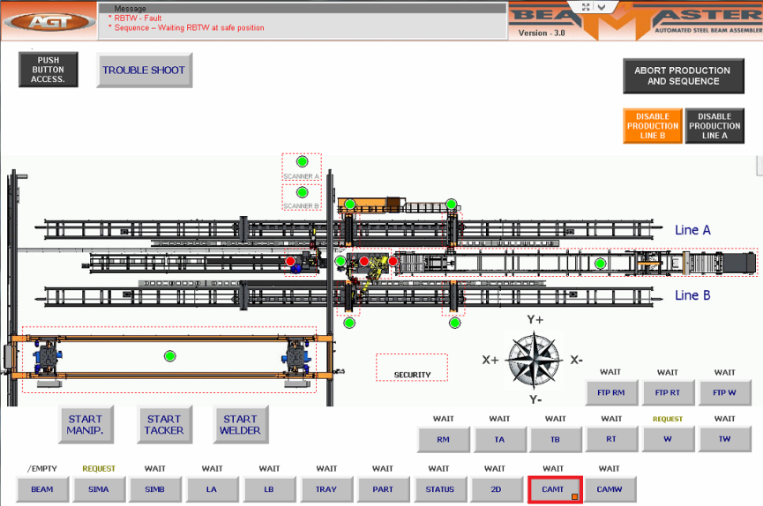

* Window of Service CamT will popup (add Picture)
* Press the HOLD button

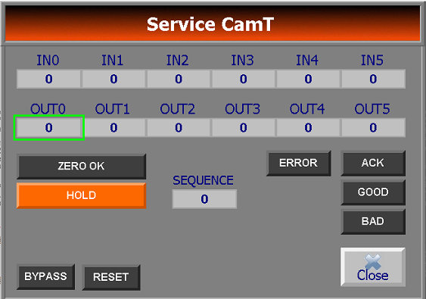

* Double Click on field ‘OUT0’
* Enter the Number 8 (pre-save mode)
  + From virtual Keyboard Press the Button 8

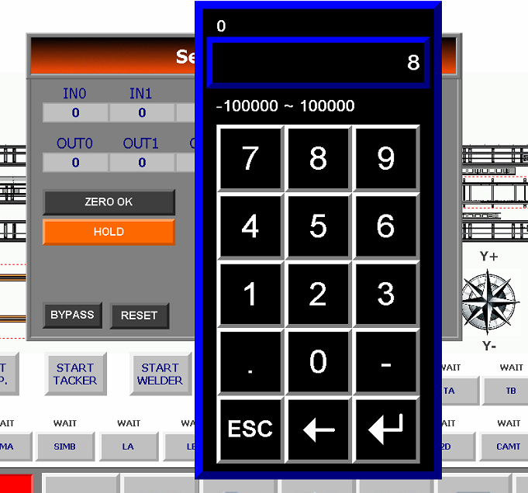

* + Press Enter

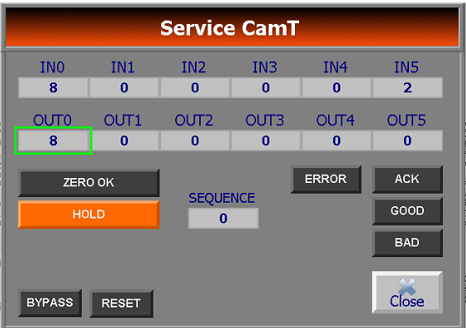

* On OUT1 Enter the last Beam ID or last Beam ID produced
  + From Virtual Keyboard press the Beam ID number

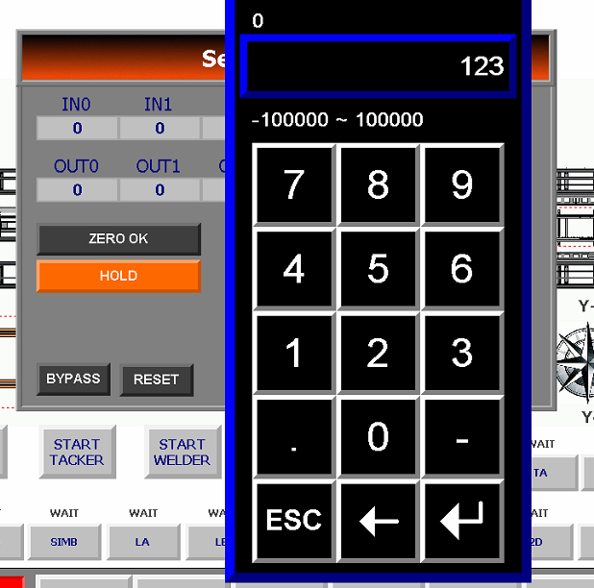

* + Press Enter

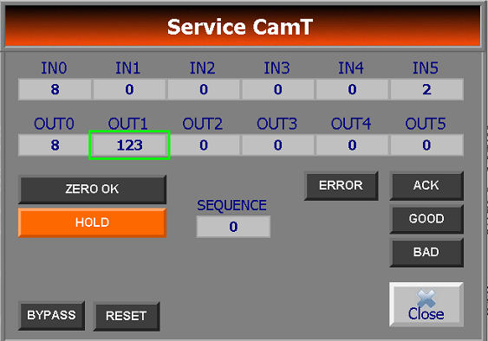

* Inform the person holding the Teach Pendant that you are ready for the first Scan
  + The person performs the first scan when done will inform you. The program will reach the last Line with mention of ‘END’ (ou sera rendu le teach pendant pour dire que c’est fini? Sur quelle ligne…)
  + From the Service CamT you will Change the Value of OUT0 to 10.

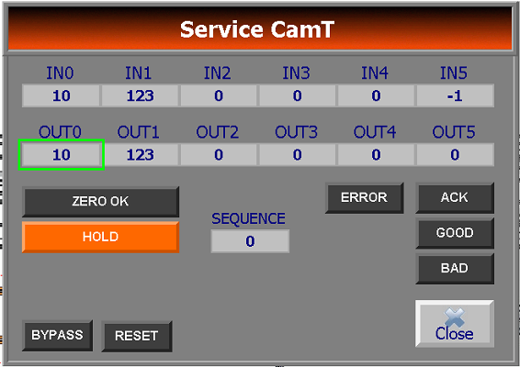

* + This will save the image under the following path: C:\Orus\images\Xscanner Tacker\
    - The file name comes as follows T0_0.tiff.
    - Since it is the first picture scan rename it as follows:
    - 1T0_0 you will need to rename the files according to the number of scans performed.
  + Once renamed Change again the value of the OUT0 back to 8 to be ready for the next Scan.



* + Inform the person that you are ready for the second scan
  + You perform these steps FIVE times. See the picture below as an example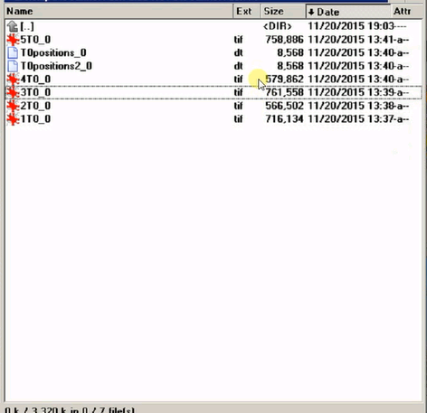

For the Calibration of the RBTW Xscan, repeat the steps above from the CAMW

The files will be saved in the following Folder:

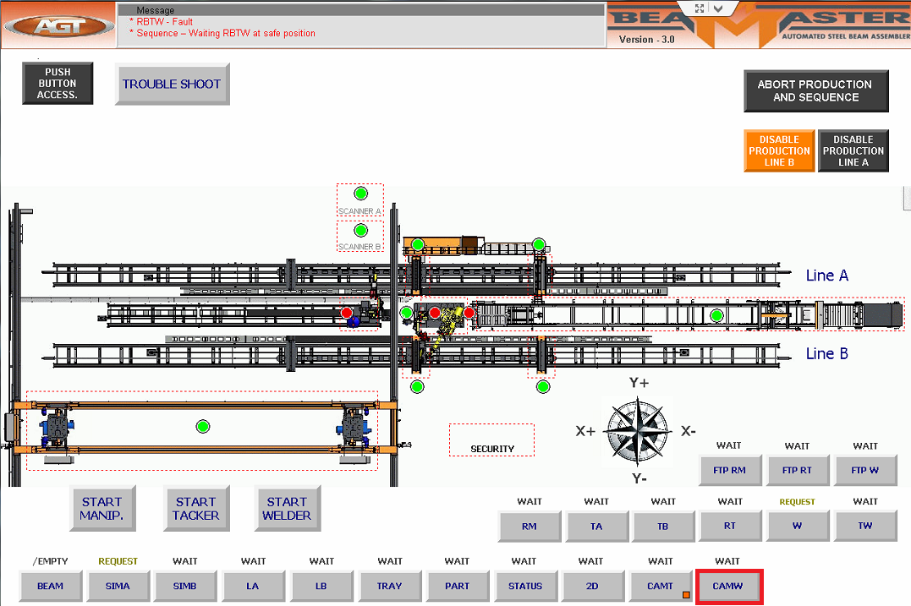

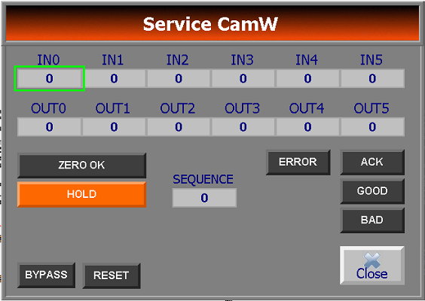

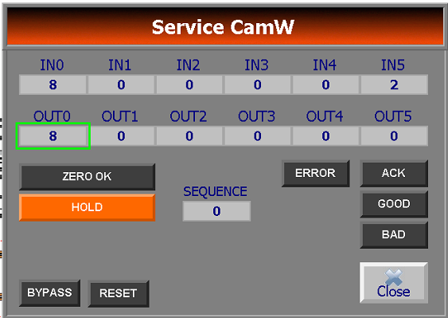

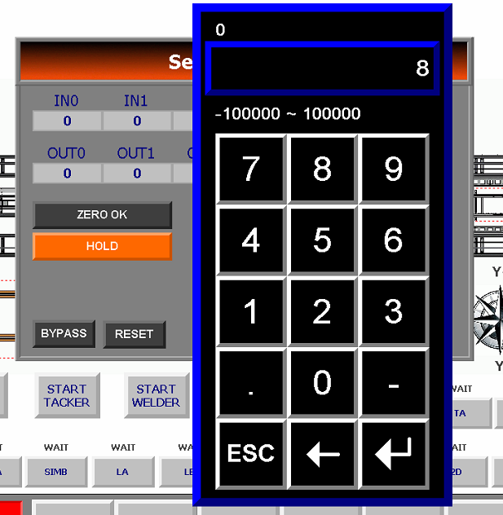

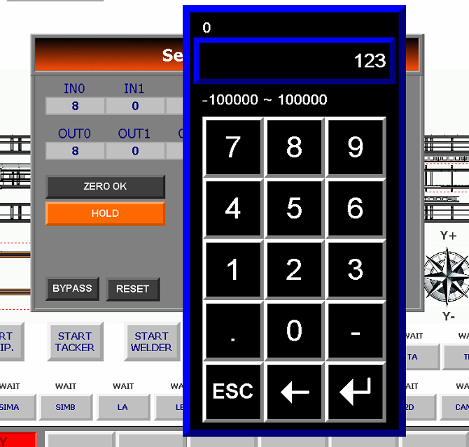

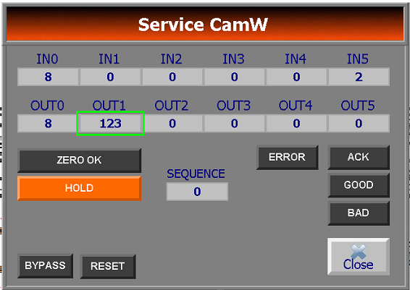

(Video for the Xscan calibration)…

Il ne faut pas refaire le TCP une autre fois apres??

## Calibration Boulier for Trolley A and Trolley B (TA, TB)

* Move the trolley line A or B to have easy access to load the calibration tool.
* Install the scanner calibration tool (ball pattern) on the proper trolley: picture
  + Open clamps on trolley.
  + Bring A3 or B3 beside A2 or B2.
  + Put the tool on both trolleys within the plastic feet. picture
  + Tool must be aligned and seated against the inside trolley stopper. picture
  + Clamp the tool on trolley by moving the outside clamp A2 or B2 in the inside direction. picture
  + Ensure that the tool is properly seated on its plastic feet and securely clamped. picture
  + Connect tool signal cable to the trolley (A2 or B2) electrical junction box cable. picture
* Perform the TCP calibration procedure to ensure correct TCP.

# Calibration with Boulier

## Calib Boulier Manip

To perform the Calib Boulier Manip you must install the Calibration Plate as mentioned the Calib Manip Section above.

On first Display screen of the Manipulator Teach Pendant (add Picture).

There is a program called ‘G1_Plate_On_Off’. This program will place the Manipulator in the proper position to place the Calibration Plate. (Add picture of the Manipulator Calibration Plate). Once done you reselect this program for you to be able to remove the calibration plate.

1. From the RBTM Teach Pendant:
   1. Select First Display with the Display button
   2. Click on the Select button
   3. Scroll down with arrows until you see G1_Plate_on_off program
   4. Click Enter
2. From Teach Pendant Press the Deadman switch (under teach pendant)
   1. Click Shift + Forward(once) Keep the Shift button pressed
   2. Until you see a message on the Teach Pendant informing that you can Place the plate

Once the Manip is in position, the magnet status will change to off. This will let you place the plate.

* 1. From teach pendant change the DI?? [Magnet] to On by Pressing F4 (Not Sure) demande a MAA

1. RBTM from teach pendant select Calib_boulier_Manip (In T1 Mode).
   * 1. Press Enter
     2. Click on the Deadman switch (below)
     3. Click on Shift Button and on Forward (once but Keep the Switch button pressed)
     4. Once Done do the same to RBTT (Tacker) (quand il va savoir que c’est done??)

## Calib Boulier Tacker

1. From the Teach Pendant of the Tacker:
   * 1. Select the Program: Calib_Boulier_Tacker.
     2. Press Enter
     3. Click on the Deadman switch (below)
     4. Click on Shift Button and on Forward (once but Keep the Switch button pressed)
     5. Once Done you move to the RBTM (Tacker)

## Calib Boulier Welder

1. From the teach Pendant of the Welder:
2. Select Calib_Boulier_Welder (ensure you are in T1 Mode).
3. Press Enter.
4. Click on the Deadman switch (below)
5. Click on Shift Button and on Forward (once but Keep the Switch button pressed)
6. Once Done you move to the RBTM (Tacker)

# Calibrate Scanner A and B

You need to keep the Boulier on the Trolley’s to perform this calibration

* From the HMI Console Pannel
  + Click on Settings
  + Click on button ‘Activate Calibration’
* If the Boulier is installed on Line A
  + Click Calibrate Scanner A.
  + This will be done automatically and all calculation will be performed in the back ground.
* If the Boulier is installed on Line B
  + Click Calibrate Scanner B.
  + This will be done automatically and all calculation will be performed in the back ground.

Once done deactivate the buttons Scanner Calibrate Scanner A or B by clicking again on them (add pictures)

Then when done Deactivate the ‘Activate Calibration’ Button by Clicking on it.

One note if calibrating the Tacker and the Welder you must restart the services twice.

If calibrating the Manipulator you must restart the services once.

If you do not do so the new settings will not be taken/activated.

You have to remove the Boulier from trolleys and the Ball Tips when all done and finished…